DNA Replication

This is where DNA identically replicates itself.

There are 4 stages of DNA replication:
- Helicase breaks the bonds between the 2 DNA strands, unzipping the DNA.
- Free nucleotides go to and attach to both open strands of the DNA, with complementary base pairing.
- DNA polymerase joins the nucleotides back onto the backbone by phosphodiester bonds.
- On the lagging strand, the sections need to be joined together by the ligase enzyme.

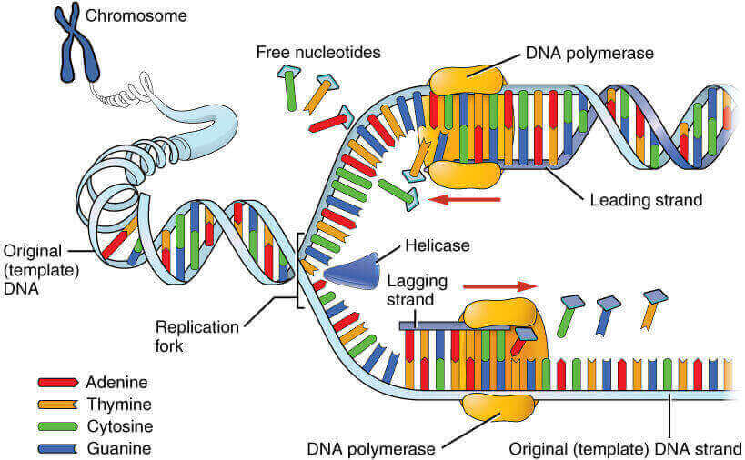
This is known as semi-conservative replication, as half of the DNA in the new piece is from the original, and half is new.

DNA helicase unzips the DNA.

DNA polymerase joins up nucleotides.

DNA ligase joins up segments of newly formed DNA.

How this was determined

Meselson and Stahl were two scientists who proved that DNA replication was semi-conservative. They did this with an experiment:

- Bacteria were grown in an environment with only nitrogen 15. This is a heavy nitrogen isotope which is not common. All the bacterial DNA is made with nitrogen 15 as it is the only nitrogen source.
- The bacteria are transferred to an environment with only nitrogen 14, and after a generation, new bacteria are formed. All of their DNA is comprised of hybrid DNA, which is half nitrogen 15, and half nitrogen 14.
- After a second generation, half the DNA is hybrid DNA, and half of the DNA is made entirely of nitrogen 14.
- After a third generation, ¾ of the DNA is entirely nitrogen 14, and only ¼ is hybrid.
